Trends in living arrangements of Belgian elderly
and its impact on mortality

Anne Herm, Luc Dal and Michel Poulain

Research questions
Beside age and sex, the living arrangements, with whom a person live, and marital status are largely used to explain the variation of mortality risks for the older adults. Trends in family and household composition have been in interest of demographers but less is known about trends in living arrangements of elderly population and its possible impact on mortality. These trends are associated with steadily improving longevity in the context of population ageing but also with the impact of the second demographic transition characterised by increasing individualisation in demographic behaviour. Studies suggest that not only distribution of living arrangements is affected by the mortality improvements but also that different living arrangements have specific association with mortality risks. This raises a question if and how trends in living arrangements of the elderly could be reflected in mortality improvement. More precisely we intend to check (i) how changes in the structure of the older adults by living arrangements could impact the improvement in longevity and (ii) if the change observed in the association between specific living arrangements and mortality risks could also impact the change in mortality. As some living arrangements are more favourable for survival in old ages than others, some observed relative changes in the distribution of older people by living arrangements might favour or reduce the improvement in mortality. Moreover, the convergence in the association between living arrangements and mortality risks and the smaller variation of mortality risks between living arrangements in advanced ages could counter-balance this effect.

Data used and typology of living arrangements
To assess the impact of the trends of living arrangements on mortality improvement we use Belgian data from national population register and consider a detailed typology of living arrangements combining the types of co-residence and marital status. Using register data, we had a unique possibility to follow the living arrangements of the population aged 60 years and over from 1991 to 2013. That allowed capturing the emergence and change of some types of living arrangements by age and in time, and their effect to the overall mortality outcome. The population of interest includes 2.1 million persons on 1 January 1991 and increases up to 2.6 million on 1 January 2013 and a total of 2 million deaths were registered during the period of observation.
The typology of living arrangements used in this analysis is based on the type of household, the individual relationship with the person of reference and the marital status. Three broad groups of living arrangements are distinguished: a) persons living alone; b) persons living with a spouse, partner or other persons in private household, and c) persons living in collective households (mainly nursing homes). For persons living alone or in collective living arrangements we distinguish also marital status by considering separately single, widowed and divorced or separated.

Results
Trends in older population by living arrangements
The growth of the Belgian older population is remarkable in the context of the overall population ageing. The share of men in this age increased by 35 % between years 1991 and 2013, and of women by 21% whereas in absolute numbers the increase was about 300 000 in both gender (Figure 1). This increase of the population is due to the combined effect of the increasing longevity and larger cohorts reaching in older ages.

Figure 1. Absolute and relative increases of the male and female populations aged 60 and over from 1991 till 2013.
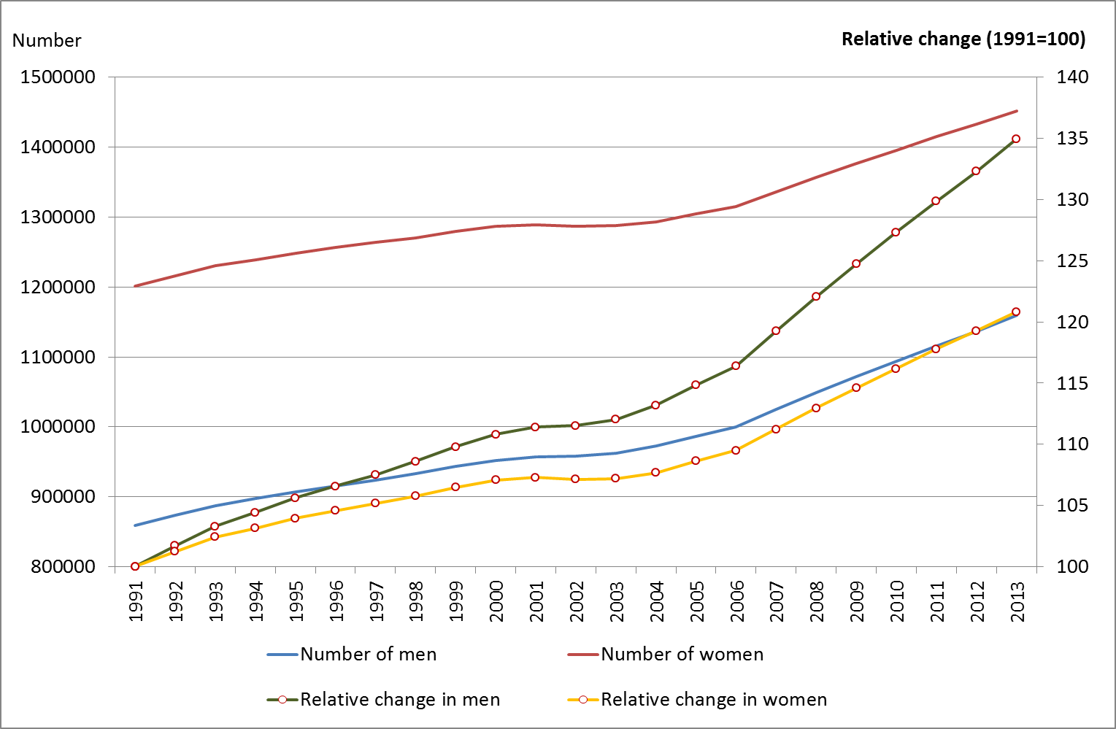

As the absolute number of older population increases, we may expect the respective increase in total numbers in each living arrangement accordingly. Yet, such trend does not appear in all living arrangements equally. Absolute numbers reveal that number of older people who live with a spouse has increased compared with the beginning of the 1990s. In relative terms the number of men living with a spouse almost did not change while the share of women living with a spouse increased remarkably – 20% more women lived with spouse in 2013 compared to 1991. This refers to an important improvement in survival of men that mostly took place within first half of the observed period. Men and women living alone showed an increase in absolute numbers, yet a relative decrease is observed during the first half of the period and this decrease was more pronounced for women. For men the share of living alone dropped only slightly and started to increase quite rapidly in turn of millennium. Living with child or other persons but without spouse became less frequent in relative terms among both men and women. The only private living arrangements were both men and women demonstrated increase compared to 1991 level was living with an unmarried partner, this living arrangement reached almost a 58% higher level for men and 47% for women. In conclusion, we observe an increase of older people living alone and living with spouse or with an unmarried partner compared to relatively smaller changes in the number of persons in other living arrangements including in collective households.

Change in mortality risk of population 60 by living arrangements
We used survival analysis to identify trends in mortality risks by living arrangements. Figures 2a and 2b, respectively for men and women, show for each living arrangement the odds to die during one year by year with 1991 as reference. For both men and women, the mortality risks decreased linearly for all living alone or living with others in private household whereas it did not change or even increase for those living in collective households. The worse situation concern married men and divorced women in collective household. A larger improvement is found for men living with a spouse or with partner and for women living with a spouse. For these groups the mortality risks show a decrease of 40% between 1991 and 2012.

Figure 2a. Relative change in odds to die by year (1991 = ref) for men aged 60+

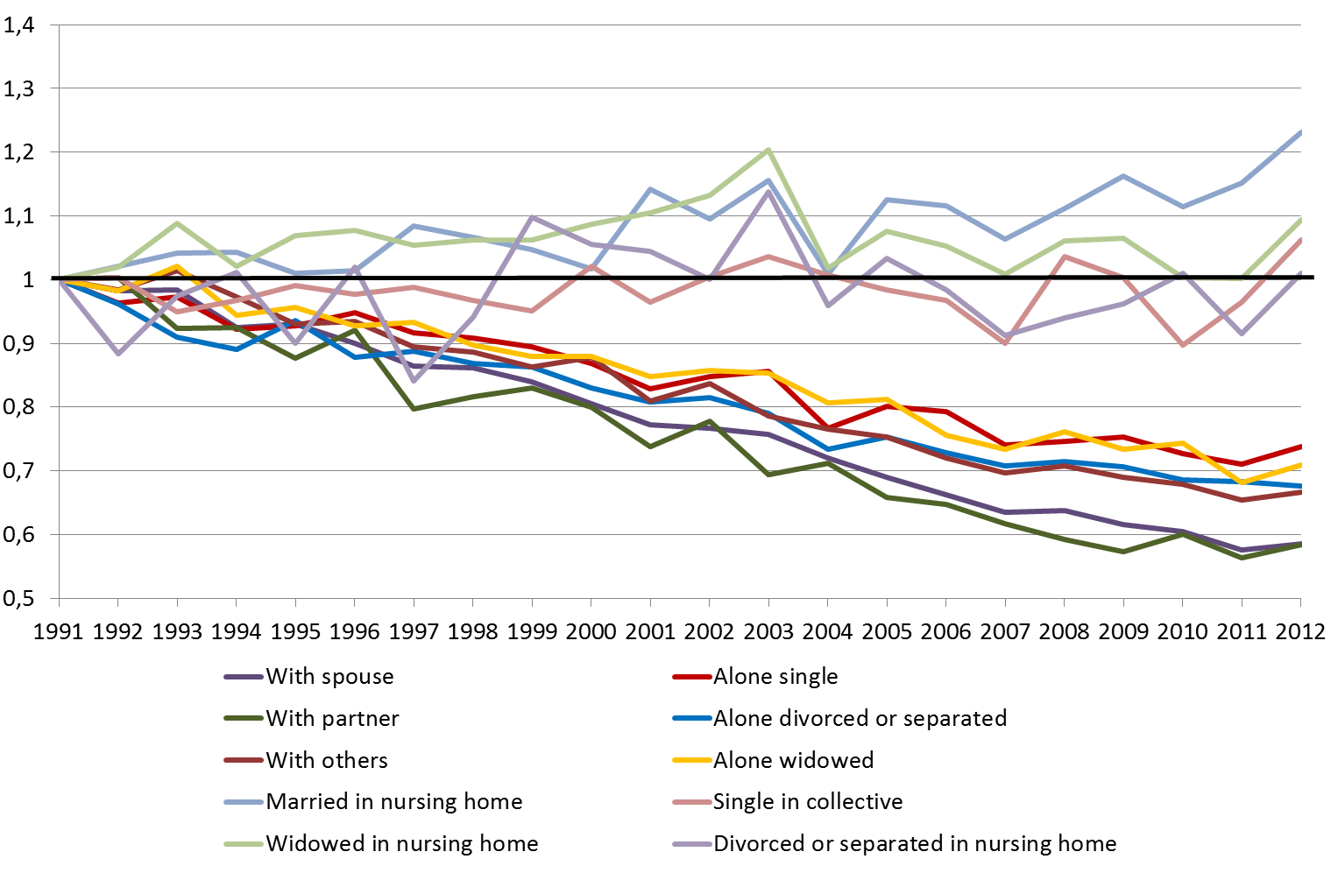

Figure 2b. Relative change in odds to die by year (1991 = ref) for women aged 60+

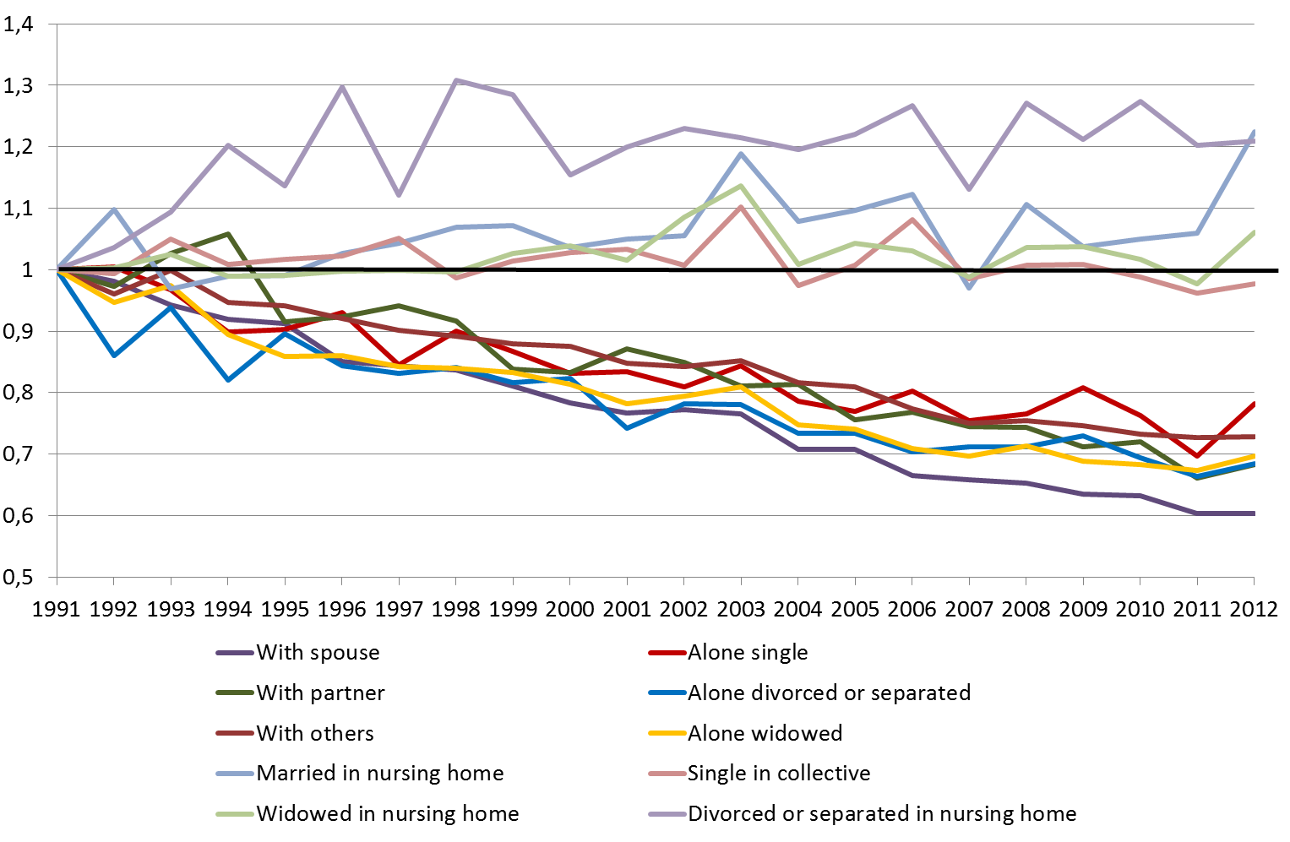

To disentangle the impact of the relative changes in the structure of the population by living arrangements we compare the observed average number of deaths for the years 2010-2012 with the absolute numbers of deaths expected in average for the same years under the following conditions:
- The share of population by living arrangements for a given sex and age group is kept unchanged in 2010-2012 compared to 1991-1993 (column B).
- The relative mortality risk by living arrangements is kept unchanged in 2010-2012 compared to 1991-1993 (column C).
In the first exercise, the number of expected deaths is obtained by applying the mortality risks observed by living arrangements in 2010-2012 to the population observed these years distributed by living arrangements as in 1991-1993 (column B). Accordingly, the ratio A/B put in evidence the impact of the relative changes in the structure of the population by living arrangements.
In the second exercise, the number of expected deaths is obtained by applying to the population observed in average for the years 2010-2012 the mortality risks by living arrangements obtained by considering the overall mortality risks observed in 2010-2012 distributed by living arrangements as observed in the years 1991-1993 (column C). Accordingly, the ratio A/C put in evidence the impact of the relative changes observed in mortality risks by living arrangements.
Table 1. Observed number of deaths (A) and expected number of deaths if the structure of the population by LA is unchanged between 1991-1993 and 2010-2012 (B) or if the relative mortality by LA is kept unchanged for the same period (C). Corresponding ratio between observed and expected number of deaths (respectively D et E).

Living | Men |  |  |  |  |  | Women
arrangements | A | B | C | A/B (%) | A/C (%) |  | A | B | C | A/B (%) | A/C (%)
Alone single | 1660 | 1572 | 1478 | 105,6 | 112,3 |  | 1134 | 1459 | 1124 | 77,7 | 100,9
Alone widowed | 6110 | 7639 | 6017 | 80,0 | 101,5 |  | 13833 | 14517 | 14662 | 95,3 | 94,3
Alone divorced or separated | 2562 | 1338 | 2330 | 191,4 | 110,0 |  | 1797 | 887 | 1802 | 202,6 | 99,7
With spouse | 21155 | 18761 | 22732 | 112,8 | 93,1 |  | 8973 | 6307 | 10145 | 142,3 | 88,4
With partner | 1410 | 1028 | 1544 | 137,1 | 91,3 |  | 697 | 494 | 734 | 141,2 | 95,0
With others | 5448 | 7781 | 5426 | 70,0 | 100,4 |  | 7803 | 11663 | 7838 | 66,9 | 99,6
In collective single | 1341 | 1245 | 914 | 107,7 | 146,7 |  | 829 | 643 | 593 | 128,9 | 139,9
In collective married | 922 | 1172 | 664 | 78,6 | 138,7 |  | 1486 | 2308 | 1210 | 64,4 | 122,8
In collective widowed | 2522 | 3479 | 2014 | 72,5 | 125,2 |  | 11362 | 11470 | 9343 | 99,1 | 121,6
In collective divorced | 561 | 237 | 364 | 236,2 | 153,9 |  | 757 | 375 | 511 | 202,1 | 148,3
All living arrangements | 43690 | 44253 | 43484 | 98,7 | 100,5 |  | 48671 | 50124 | 47962 | 97,1 | 101,5

Discussion
The more important changes in the structure of the population by living arrangements are, for men, the decreasing number of those living with others, living in collective household (being married or widowed) and widowed living alone. For women, the decrease of single living alone is also contributing to the reduction of the number of deaths. At contrary, the living arrangements responsible for increasing the number of death or at least reducing the mortality improvement are, for both men and women, the divorced persons living alone or in collective household and those living with partner. The more important changes observed in mortality risks by living arrangements concern on the positive viewpoint those living with spouse and with partner, particularly for men. On the negative side the increase of mortality risks in collective households is notable.

